LAB 6

Exercise 1 — Basic: Abstract Shape
File: ShapeDemo.java
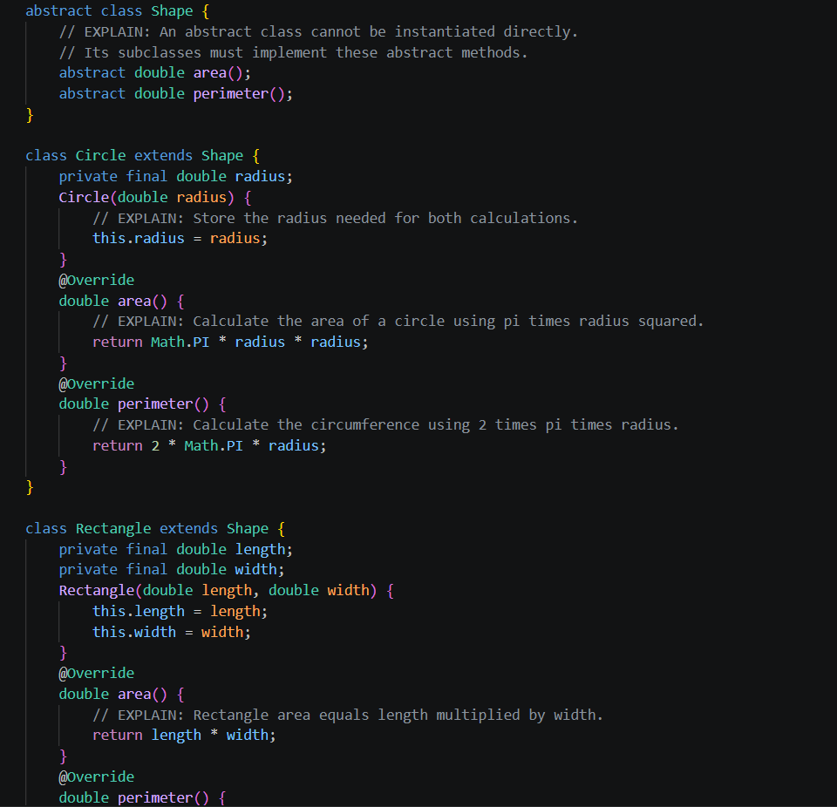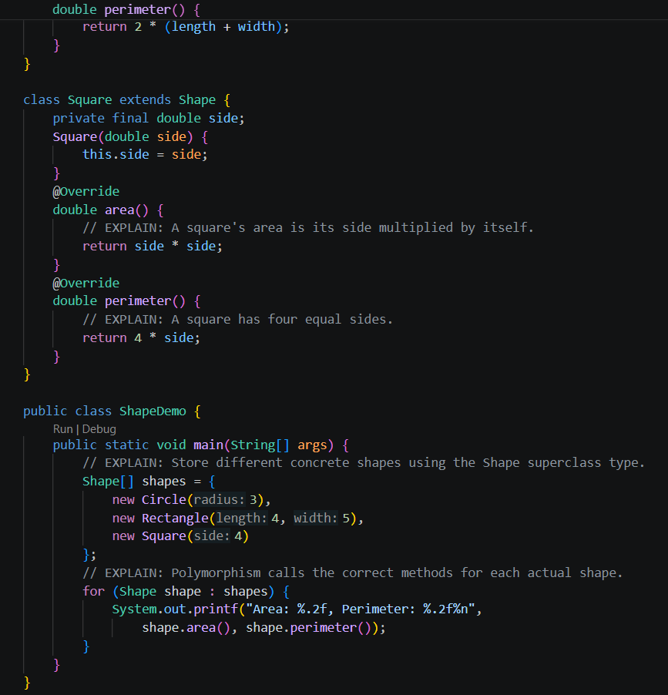
Output:


Exercise 2 — Basic: Flyable Interface
File: FlyableDemo.java
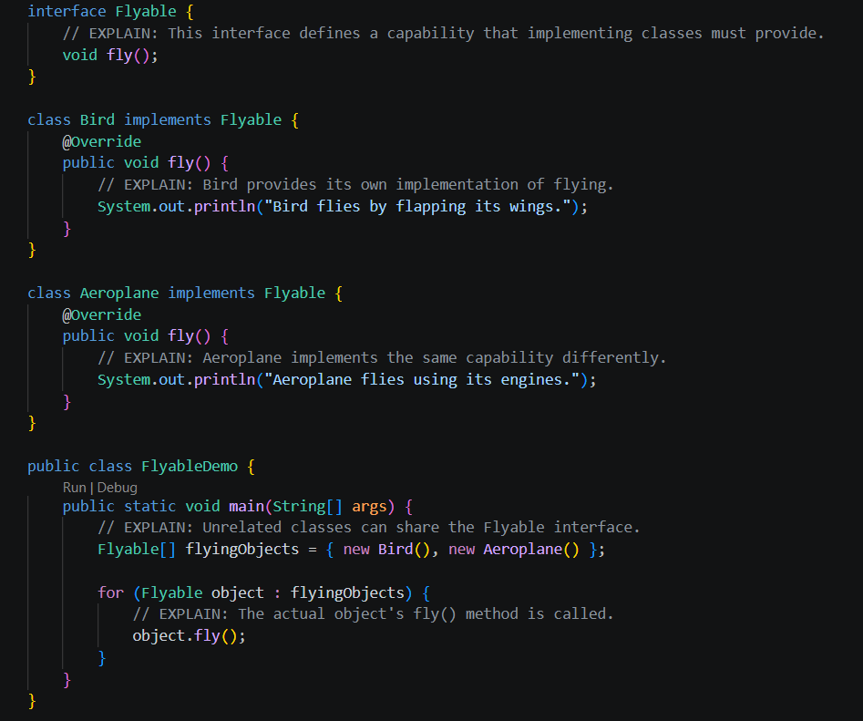

Output:

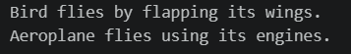

Exercise 3 — Intermediate: Abstract Account
File: AccountDemo.java
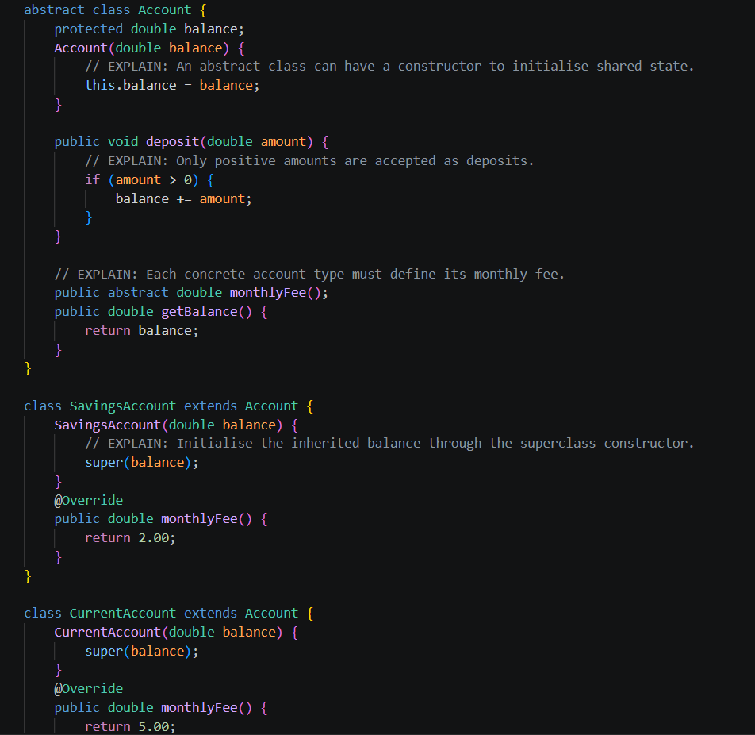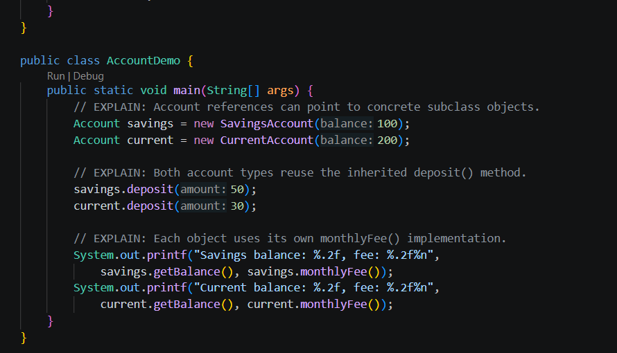
Output:


Exercise 4 — Intermediate: Comparable and Comparator
File: StudentSortingDemo.java
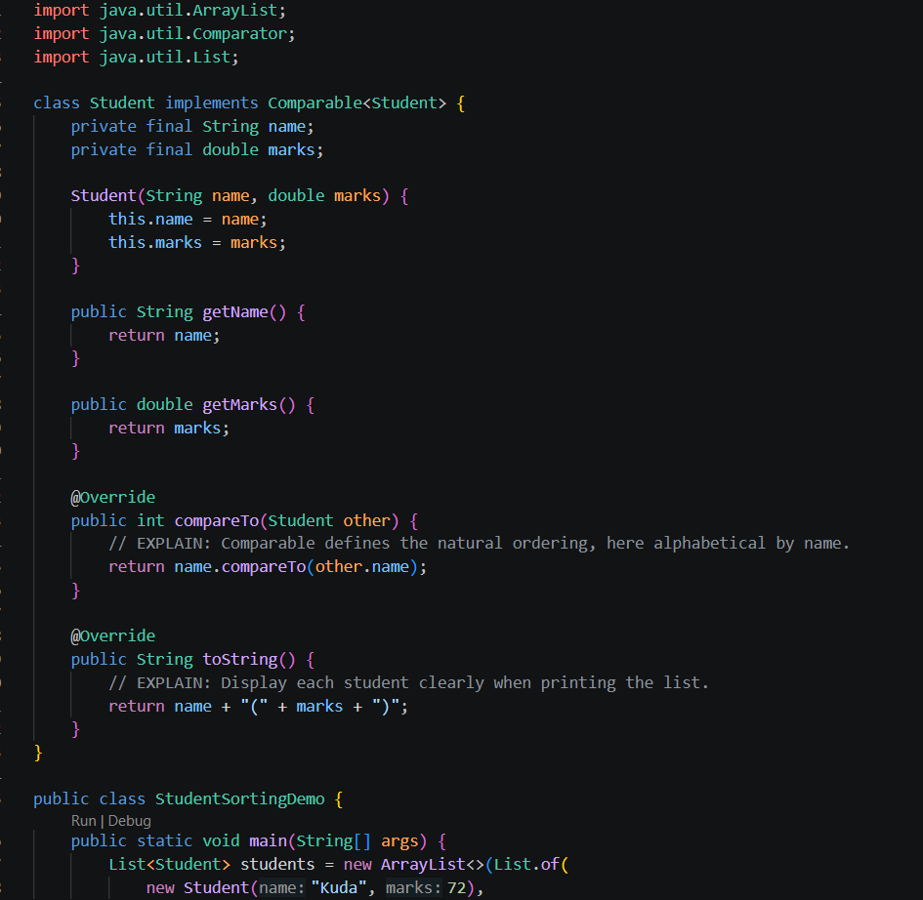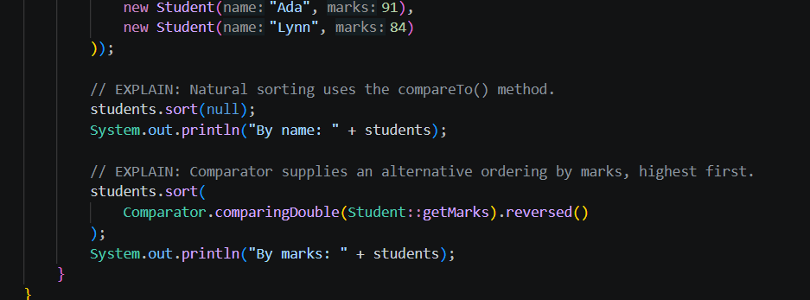
Output:


Exercise 5 — Challenge: Conflicting Default Methods
File: DefaultMethodDemo.java
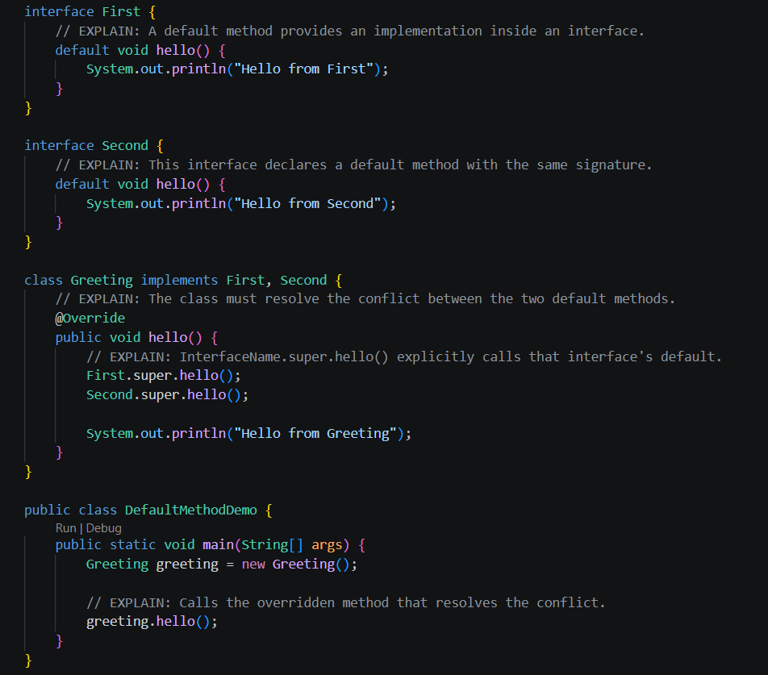

Output:
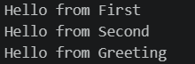

Rule explained
When two interfaces provide a default method with the same signature, the implementing class must override that method to resolve the conflict. It can call either interface's implementation using InterfaceName.super.hello().

